Space oddity

David Bowie

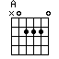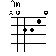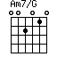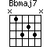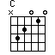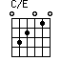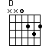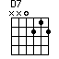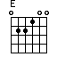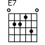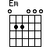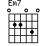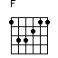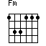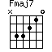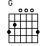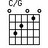

 | 157
Title: Space Oddity (David Bow | ie)

 | C | Em | C | Em
 | Ground control to Major | Tom | Ground control to Major | Tom:

 | Am | Am7/G | D7
 | Take your | protein pills and | put your helmet on

 | C | Em | C | Em
 | Ground control to Major | Tom: | Commencing countdown engine's | on

 | Am | Am7/G | D7
 | Check ig- | nition and may | God's love be with you

 | C | E7 | F
 | This is ground control to Major | Tom, you've really made the | grade!

 | Fm | C/E | F
And the | papers want to | know whose shirts you | wear,

 | Fm | C/E | F
now it's | time to leave the | capsule if you | dare

 | C | E7 | F
 | This is Major Tom to ground con- | trol, I'm stepping through the | door

 | Fm | C/E | F
And I'm | floating in the | most peculiar | way

 | Fm | C/E | F
and the | stars look very | difeerent to | day

 | Fmaj7 | Em7 | Fmaj7 | Em7
For | here am I | sitting in a tin can, | far above the | world

 | Bbmaj7 | Am | G | F
 | Planet Earth is | blue and there's | nothing I can | do

 | C | F | G | A | A | C | F | G | A | A | Fmaj7 | Em7 | A | C | D | E | C | E7 | F
 |  |  |  |  |  |  |  |  |  |  |  |  |  |  |  |  | Though I'm passed one hundred thousand | miles, I'm feeling very | still

 | Fm | C/E | F
And I | think my spaceship | knows which way to | go,

 | Fm | C | F
tell my | wife I love her | very much she | knows

 | G | E7
 | Ground control to | Major Tom:

 | Am | Am7/G
Your | circuit's dead, there's | something wong.

 | D7
Can you | hear me Major Tom?
 | C/G
Can you | hear me Major Tom?

 | G
Can you | hear me Major Tom? Can you ...

 | Fmaj7 | Em7 | Fmaj7 | Em7
 | Here am I | floating round my tin can, | far above the | moon

 | Bbmaj7 | Am | G | F
 | Planet Earth is | blue and there's | nothing I can | do

 | C | F | G | A | A | C | F | G | A | A
 |  |  |  |  |  |  |  |  |  | CHORDS: Fmaj7 x 3 3 2 1 0 C/E 0 3 2 0 1 0

Am7/G x 0 3 0 2 1 C/G 3 3 2 0 1 0

Bbmaj7 x 2 3 2 3 1

